MADAN BHANDARI MEMORIAL COLLEGE
New Baneshwor, Kathmandu
Phone: 5172175/5172682
www.mbmc.edu.np


Simulation & Modelling -Lab Report

Submitted By – Reeju Pandit  Semester – 5th  Section - B  Roll No. - 18 | Submitted To – Saroj Mahto  Lecturer-Simulation & Modelling  BSc. CSIT

Madan Bhandari Memorial College
Department of Computer Science and Information Technology (Bsc.csit)
Binayak Nagar, New Baneshwor, Kathmandu
Practical Index Page
Subject Simulation & Modelling
Name: Reeju Pandit Semester: 5th Roll no: 18 Section: B
TABLE OF CONTENT
S.N | Details | Submission Date | Signature | Remarks
1. | Lab-1
2. | Lab-2
3. | Lab-3
4. | Lab-4
5. | Lab-5
6. | Lab-6 Q no 5
7. | Lab-6 Q no 6

Lab no: 1
Title: Write a C program to find the growth in national consumption for five years
using Distributed Lag Model given below:

I = 2 + 0.1 Y-1
Y = 45.45 + 2.27 (I +G)
T = 0.2 Y
C = 20 + 0.7 ( Y – T )
Assume the initial value of Y-1 is 80 and take the governmental expenditure in
the 5 years to be as follows:
Year G
1 20
2 25
3 30
4 35
5 40

Source Code:
#include<stdio.h>
#include<conio.h>
int main()
{
float Y_1,Y,I,T,C[5];
float G[5]={20,25,30,35,40};
int i;
printf("\n By Reeju Pandit\n");
printf("Enter initial value of lagged variable Y_1:");
scanf("%f",&Y_1);
printf("\nThe growth in consumption is given following tables:\n");
printf("\nYear \t \t Consumption\n");
for(i=0;i<5;i++)
{
I=2+0.1*Y_1;
Y=45.45+2.27*(I+G[i]);
T=0.2*Y;
C[i]=20+0.7*(Y-T);
printf("\n %d \t \t %.2f",i+1,C[i]);
Y_1=Y;

}
getch();
return 0;

}

Output:

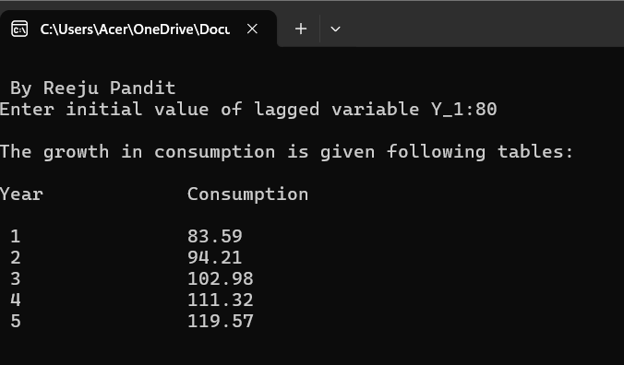

Lab no:2
Title: Customers arrive in a bank according to a Poisson's process with mean inter arrival time of 10 minutes. Customers spend an average of 5 minutes on the single available counter, and leave.
Write a program in C to find:
I. Probability that a customer will not have to wait at
the counter.
II. Expected number of customers in the bank.
III. Time can a customer expect to spend in the bank.

Source Code:
#include<stdio.h>
#include<conio.h>

int main()
{
float l,m,e;
float p,et;
printf("\n By Reeju Pandit\n");
printf("Enter Inter arrival time of customers per hours:");
scanf("%f",&l);
printf("\nEnter The average time spent by cutomers per hour:");
scanf("%f",&m);
p=1-l/m;
e=l/(m-l);
et=1/(m-l);
et=et*60;
printf("\nThe probability That a customer wont't have to wait at counter:%f ",p);
printf("\n\nExpected number of customer: %f",e);
printf("\n\nExpected time to be spent in bank: %f minutes",et);
getch();
return 0;
}

Output:
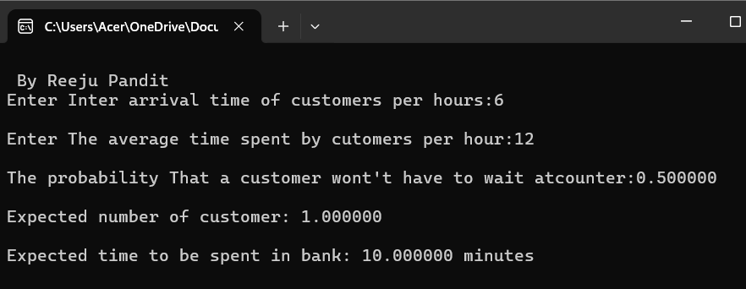
Lab no:3
Title: At the ticket counter of football stadium, people come in queue and purchase tickets. Arrival rate of customers is 1/min. It takes at the average 20 seconds to purchase
the ticket.
WAP in C to calculate total time spent by a sports fan to be seated in his seat, if it takes 1.5 minutes to reach the correct seat after purchasing the ticket.
if a fan comes exactly before 2 minutes before the game starts, can sports fan expects to be seated for the kick-off?

Source Code:

#include <stdio.h>

int main() {
printf("\n By Reeju Pandit\n");

float arrival_rate = 1.0; // ? = 1 customer per minute
float service_time = 20.0 / 60; // 20 seconds = 0.333 minutes
float service_rate = 1.0 / service_time; // µ = 3 per minute
float walking_time = 1.5; // time to seat after ticket
float arrival_before_game = 2.0; // fan arrives 2 minutes early

float rho = arrival_rate / service_rate;

// Waiting time in queue using M/M/1 formula: Wq = ? / (µ - ?)
float waiting_time = rho / (service_rate - arrival_rate);

// Total time = waiting + service + walking
float total_time = waiting_time + service_time + walking_time;

// Output
printf("\n--- Football Stadium Ticket Queue ---\n");
printf("Waiting time in queue : %.2f minutes\n", waiting_time);
printf("Ticket purchase time : %.2f minutes\n", service_time);
printf("Time to reach seat : %.2f minutes\n", walking_time);
printf("Total time before seated : %.2f minutes\n", total_time);

// Will the fan make it before kickoff?
if (total_time <= arrival_before_game) {
printf("\n? Yes, the fan can be seated before kick-off!\n");
} else {
printf("\n? No, the fan will miss the kick-off.\n");
}

return 0;
}

Output:
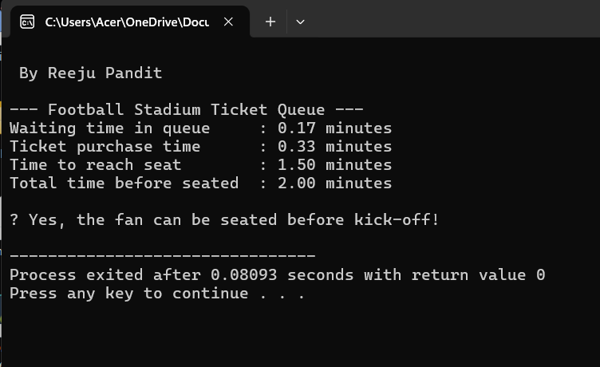

Lab no:4
Title: In a single pump service station, vehicles arrive for fueling with an average of 5 minutes between arrivals. If an hour is taken as unit of time, cars arrive according to Poison’s process with an average of
λ= 12 cars/hr.
Write a C program to generate Poisson distribution for x = 0,1,2, .... 15.
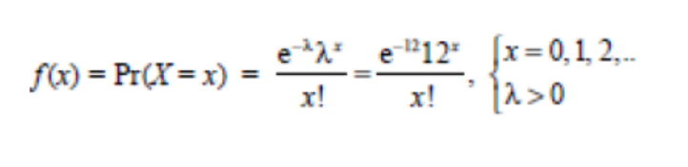
Source Code:
#include<stdio.h>
#include<conio.h>
#include<math.h>

int main()
{
float l,m,p[16],pr,x,a,i;
int j;
printf("\n By Reeju Pandit\n");
printf("Enter arrival rate per hours:");
scanf("%f",&l);
for(x=0;x<16;x++)
{
a=1;
for(i=1;i<=x;i++)
{
a=a*i;
}
pr= (pow(2.71,-l)*pow(l,x))/a;
// p[x]= (pow(2.71,-l)*pow(l,x))/a;
printf("\nP(X=%f) = %f\n",x,pr);
}

getch();
return 0;
}

Output:

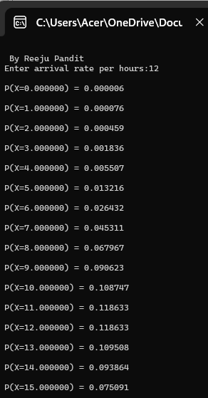

Lab no:5
Title: The probabilities of weather conditions (modeled as either rainy or sunny), given the weather on the preceding day, can be represented by a transition matrix:
0.9 | 0.1
0.5 | 0.5

The weather on day 0 is known to be sunny. This is represented by a vector in which the "sunny" entry is 100%, and the "rainy" entry is 0%:
(1 0) .
Write a C program to find the weather of the next day by using Markov Chain Method.

Source Code:
#include<stdio.h>
#include<conio.h>
int main()
{
printf("\n By Reeju Pandit\n");
float transMat[2][2]={0.9,0.1,0.5,0.5},vect[1][2]={1,0},result[1][2];
int i,j,k;
for(i=0;i<2;i++)
{
for(j=0;j<2;j++)
{
result[i][j]=0;
for(k=0;k<2;k++)
{
result[i][j]+=vect[i][k]*transMat[k][j];
}
}
}

printf("\nWeather of next day using markov chain\n\n");
for(i=0;i<1;i++)
{
for(j=0;j<2;j++)
{
printf("%f\t",result[i][j]);
}
printf("\n");
}
getch();
return 0;
}

Output:
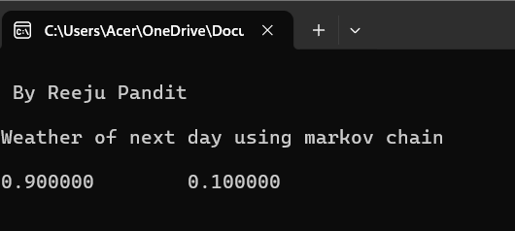

Lab no:6 Qno.5
Title: What is random number and what are its properties. WAP in C to generate 100 random numbers using Linear Congruential Method where X0=11, m=100, a = 5 and c=13.

Source Code:

#include<stdio.h>
#include<conio.h>
#define SIZE 100
int main()
{
int x[SIZE],i;
int m=100,a=5,c=13;
x[0]=11;
for(i=0;i<100;i++)
{
x[i+1]=(a*x[i]+c)%m;
}
printf("\n By Reeju Pandit\n");
printf("\nGeneration of random numbers using linear congruential method");
for(i=0;i<100;i++)
{
printf("%d\t",x[i]);
}
getch();
return 0;
}

Output:

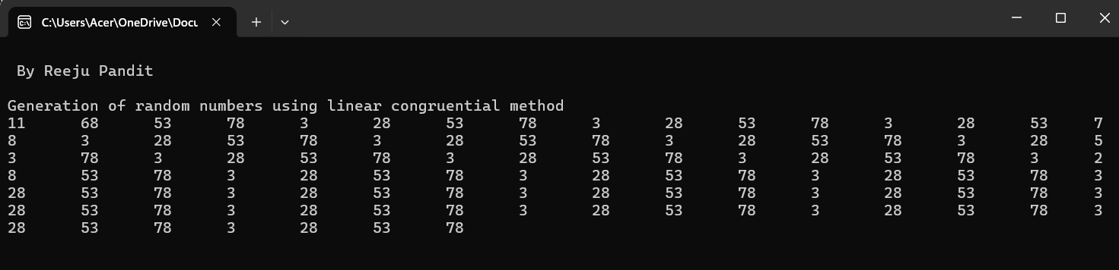

Lab no:6 Qno.6
Title: WAP in C to generate 100 random numbers using Multiplicative Congruential Method where X0=13, m =1000, a = 15 and c = 7.

Source Code:
#include <stdio.h>

int main() {
int Xn = 13;
int a = 15;
int c = 7;
int m = 1000;
int X_next;
printf("\n By Reeju Pandit\n");
printf("Generated random numbers using Multiplicative Congruential Method:\n");

for(int i = 0; i < 100; i++) {
X_next = (a * Xn + c) % m;
printf("%d ", X_next);
Xn = X_next;
}

return 0;
}

Output:
